OVERVIEW OF THE COLLECTION, PROCESSING AND RECORDING OF MLESF SUMMARY DATA

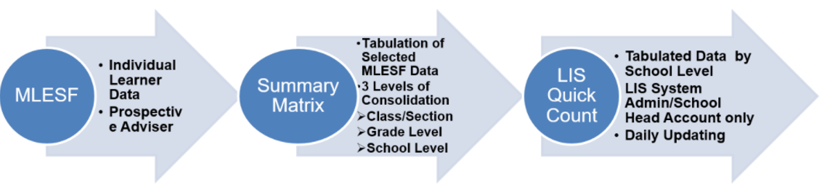

To help our schools to have a ready reference encoding summarized/initially processed MLESF data, the Planning Service is providing an option to utilize automated Summary Matrix tool before encoding data to LIS Quick Count. However, if the school prefer to use their “own consolidation tool” or strategy, they may do so provided that the data requirement in LIS Quick Count is satisfied and it will not cause delay or interruption to the daily reporting schedule in the facility.

The Illustration below shows the basic consolidation method and reporting to Summary Matrix and eventually in LIS Quick Count:
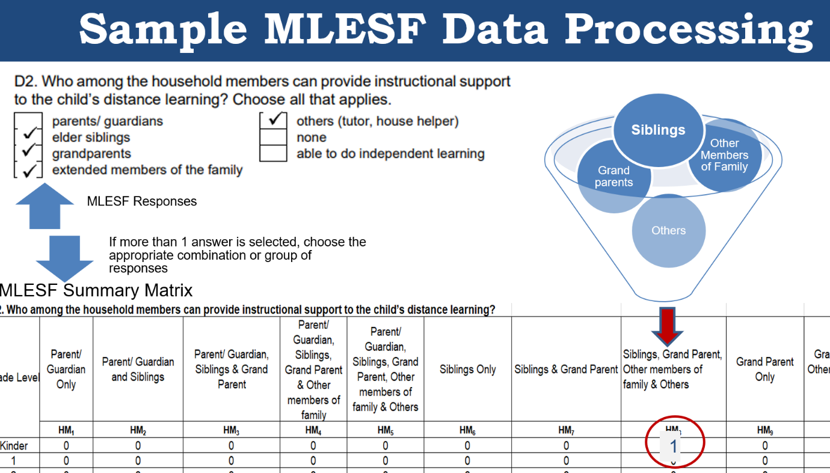

Please be reminded that in the processing of MLESF data, the following instructions shall be observed:
MLESF | Summary Matrix | LIS Quick Count Facility
C2. Highest Educational Attainment  -Father  -Mother  -Guardian | C2. Highest Educational Attainment  -Select only the individual with Highest Educational Attainment
D1. How many of your household members (including the enrollee) are studying in School Year 2021-2022? Please specify each.  - selection per learner and specific grade level | D1. How many of your household members (including the enrollee) are studying in School Year 2021-2022? -No.of Learner/s in a Household  -Total count/quantity of learner/s studying in schools in SY2021-2022  -if there are 7 or more learners attending classes, select the Column 7 or more.
D2. Who among the household members can provide instructional support to the child’s distance learning? Choose all that applies.  -selection per level of family relationship/non-relative  -extended family | D2. Who among the household members can provide instructional support to the child’s distance learning?  -Selection of an individual or combinations of family or non-family members  -other family member is equivalent to extended family
D3. What devices are available at home that the learner can use for learning? Check all that applies.  -selection of specific and per type of device/gadget or equipment | D3. What devices are available at home that the learner can use for learning?  -Selection of specific/combinations of devices/gadgets/equipment  - General specification of Television (regardless of Cable or Non-Cable TV)  - General specification of Cellular phone (regardless smartphone or basic cellphone)  - Tablet is included under the general classification of Cellularphone if tablet is among the available devices at home. If tablet is the only device available, select Tablet only in the list
D4. Is there an internet signal in your area?  -Selection for Yes or No | D4. Is there an internet signal in your area?  -Selection for Yes or No | Not Needed/Did not Ask
D5. How do you connect to the internet? Choose all that applies.  -selection of specific way/method connecting internet service | D5. How do you connect to the internet?  -Selection of particular/combination of methods connecting internet service
D6. What distance learning modality/ies do you prefer for your child? Choose all that applies.  -selection of preferred modality/ies | D6. What distance learning modality/ies do you prefer for your child?  -Selection of specific/combination of preferred modality/ies  -for combination of modalities not specified in the list, choose “blended” learning
D7. What are the challenges that may affect your child’s learning process through distance education? Choose all that applies.  -Selection of challenges | D7. What are the challenges that may affect your child’s learning process through distance education?  -Selection of specific/combination of challenges
E1. In case limited face to face classes will be allowed, are you willing to allow your child/ children to participate?  -Selection for Yes or No | E1. In case limited face to face classes will be allowed, are you willing to allow your child/children to participate?  -Selection for Yes or No | E. Are you willing to allow your child to participate in limited face to face classes? If not, please select the major consideration  -E1 & E2 was combined.  -For the “No” responses, choose major reason or consideration
E.2 If the answer is no , please select only 1 major consideration or state specific reason  - Selection of reason of hesitation | E.2 If the answer is no , please select only 1 major consideration or state specific reason  - Selection of reason of hesitation

